**Section 01 (Adding Javascript to websites):**

* You can add javascript to your website via inline method using onload attribute but this method has similar downsides to the inline css. Code example given below.

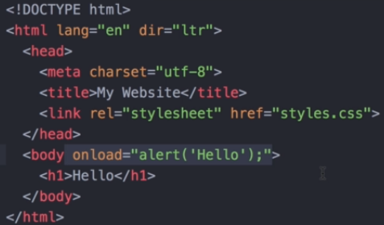

* Another way of incorporating javascript is using the script tag. And any code written in the script tag can be javascript code. Code example given below.

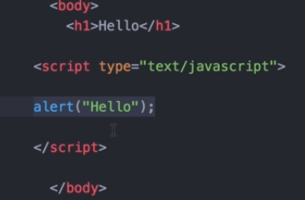

* You can also add an external javascript file using index.js. Code example given below

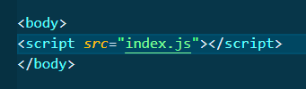

* The position of the script tag is of great importance since the browser reads the webpages from top-to-bottom.
* This is why you want to put your css right at the top (just below the title tag normally), but you would want to put your js very carefully cuz if you try to modify an element that doesn’t exist in the current HTML flow due to it being placed below your js tag your javascript is gonna fail and throw an error.
* So a good idea is to put your script tags at the bottom so that at least the body of your webpage is loaded and the parts which users can’t see (js etc), you may load that later on.

**Section 02 (Introduction to the Document Object Model (DOM)):**

* The dom converts html elements into tree like structures called objects and makes it easier to manipulate our websites and structure.

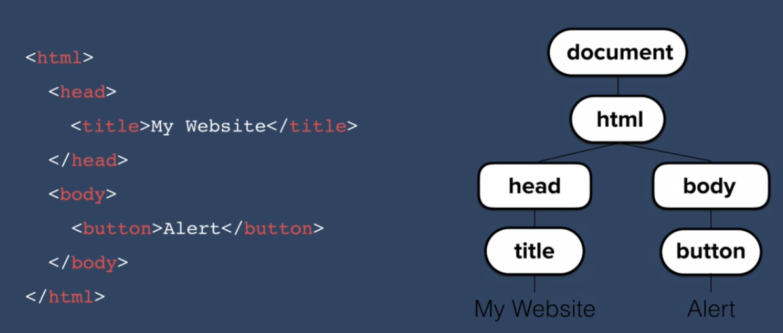

* Everything contained inside an HTML element is part of the “document”.
* Document.firstElementChild gives you the complete HTML page since the document contains the complete html.
* Document.firstElementChild.firstElementChild will give you the head tag and all its contents.
* An object may have a number of properties and objects.

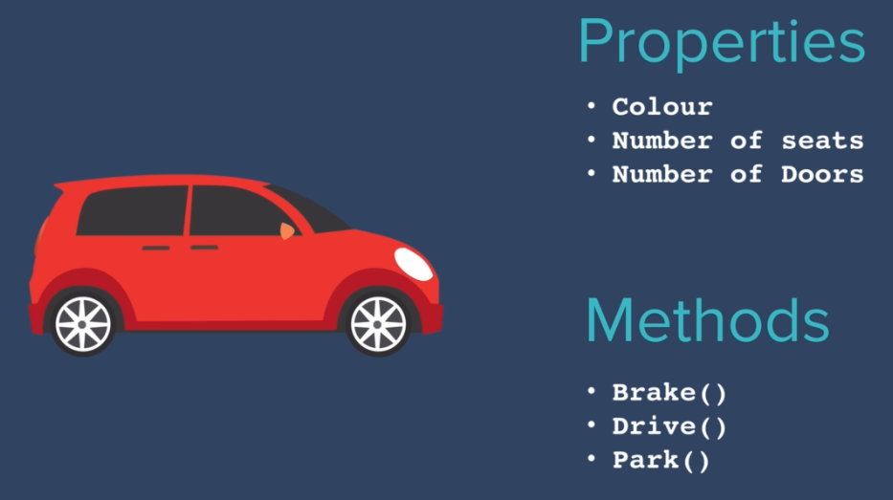

* A method is something that an object can do, while a function can stand alone too.
* The properties and methods of the button object can be given as

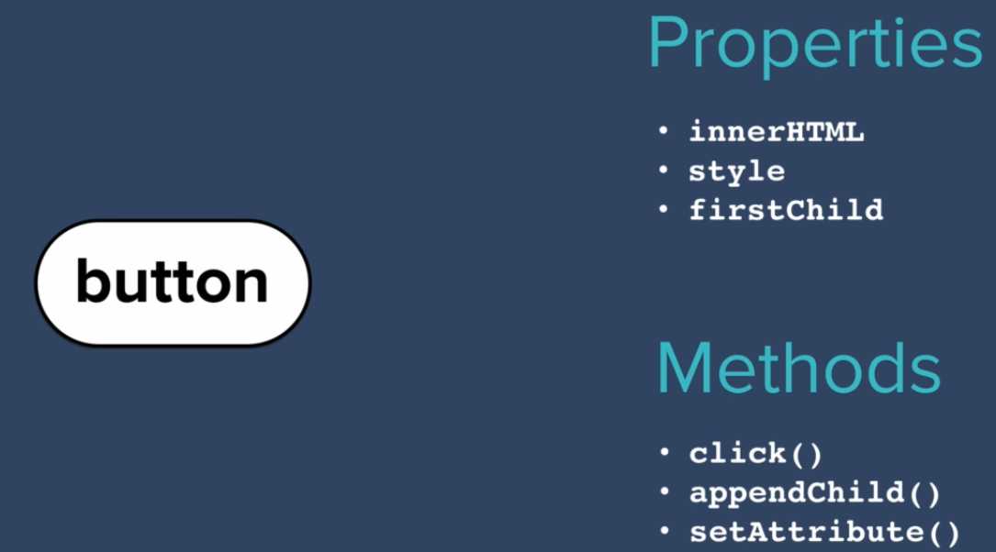

* You can ‘get’ and ‘select’ a property using object.property notation.
* You can ‘set’ an object’s property using object.property=value method.
* You can call a method on an object using object.method().

**Section 03:**

**Section 04:**

* You can select elements by **document.getElementsByTagName(“tagname”)**.
* This will select all the elements of the particular tag you have provided.



* You can also select elements based on the name of their class i.e. **document.getElementsByClassName(“className”)** function. This function will return an array and you will have to select the element by using its index.
* **getElementById(“id”)** returns a single element and works the same way.
* **Document.querySelector(“query”)** can be used to select and specifically target query selectors like we use in css by combining tags, classes and ids.
* By using query selector method if you query matches more than one element you only get back the first one.
* To select all elements you will have to use **document.querySelectorAll(“query”)** method
* **querySelector()** and **querySelectorAll()** methods are normally used more as compared to their getElement counterparts since they are more specific.

**Section 05:**

* Names of a lot of properties a little different when called in css and then changed in javascript. For Eg: font-size is used in css but in javascript we would use **document.querySelector(“h1”).style.fontSize=”10rem”**
* You can learn more about it from w3schools HTML dom style object documentation.
* In cases they are exactly the same except that we remove the dash(-) and capitalize the first letter of the second word. For eg: font-size in css and fontSize in javascript.
* The values you set it to has to be specified in string. **document.querySelector("button").style.backgroundColor="yellow"**

**Section 06 (Separation of content vs style vs behavior):**

* You should use HTML for your content.
* CSS for styling
* And Javascript for functionality.
* You can add classes to an element and the write css for that class, thus when the class is added to your element, the css will be automatically applied.
* 
* The above code adds a class “invisible” to the button element, we can pre write css selector for the invisible class and those style will be applied when we add this class to our element.
* You can also use remove to remove a class from an HTML element and use toggle to add a class if its not already present and remove a class if its already applied to the HTML element.

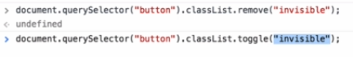

**Section 07(Text Manipulation and the text content property):**

* innerHTML will give you inner HTML inside a tag (along with strong, em tags if any), while textContent will only give you the text content after filtering out all the em, strong, underline tags etc.

**Section 08:**

* You can also change attributes of HTML elements using the following method

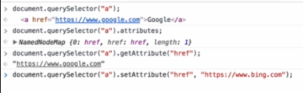

* Attribute is anything in an HTML element that doesn’t comprise of the name of the element, like ids, classes etc.